**Micro-Chip Manufacturing:**

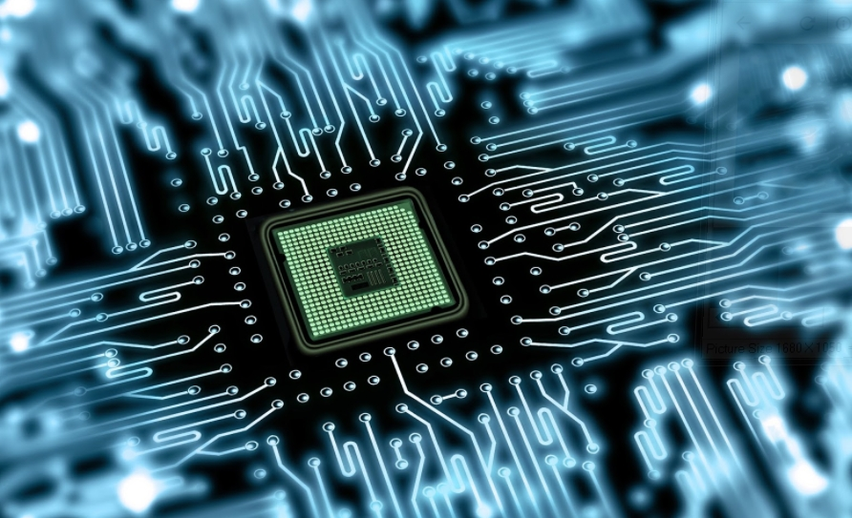

Generally people compare the microchips as it determines the specifications and performance of the device (mobiles) such as, Samsung’s its own Exynos chipset as well as Qualcomm's Snapdragon. Most Used Chipsets: Samsung. The most popular chipset, the Exynos 8890, is used in the Galaxy S7 and S7 Edge, Apple Chipsets etc. These chips have various configurations to perform certain tasks, Kirin 970 a chipset has added artificial intelligence and NPU manufactured by Huawei. Intel has laid the platform in microchip manufacture; they became pioneers in manufacturing of micro chip, that’s why Intel inside exciting features outside.

Whatever the electronic gadgets we use in our daily life the very fundamental and exciting thing is microchip, the ***heart of electronics***. How we humans have brain to organise various functions in the same way micro chip is a device for computer, mobiles, TV’s......etc. In olden days a computer is placed in a huge room now it came to pocket size due to this micro chip. Coming to the definition, a **microchip** is a unit of packaged computer circuitry (usually called an integrated circuit) that is manufactured from a material such as silicon at a very small scale. Microchips are made for program logic (logic or microprocessor **chips**) and for computer memory (memory or RAM **chips**). The main part is transistor in microchip they like neurons of the gadget these can act as switch based on binary condition since computer know only binary language(0’s and 1’s) this acts as platform to link software and hardware. Transistor has the capacity to ON/OFF 1,000,00,00,00,000 /sec. Micro chip have billion’s of transistors. To link these transistors a simulation is used known as CAD (Computer Aided Design), if it works then it is taken further steps to manufacture known as fabrication.

Let’s have a look how this exciting powerful part is manufactured, It’s basic raw material is sand because it has silicon. In order to extract Silicon, sand is heated up to 2000 0C, silicon obtained in this process is purified up to 99.99%. This molten Silicon is converted into cylindrical shape known as ingot, later ingot is cut and polished in the form of thin discs, A thin layer of photo-resist coating is applied on the disc, now the desired design is placed on the disc and U.V light is sent on the disc photo-resist coating becomes disappear on the place where U.V light is exposed and the rest gives the impression of the design this process is known as Photolithography. Now it is coated with certain dielectric materials these layers can be only seen by microscope. To have connection among transistors very thin copper wiring is placed around 30 layers, now this disc is cut into thin sub divisions like this we will get 1000 microchips per disc now a cap like structure is placed on the chip such that it protects from dust and other external means, a heat sink also embedded in the chip to prevent overheating. Now the glorious micro chip is ready. At first only 5 transistors are placed on micro chip today we see billions of transistors. We have studied the Moore’s law in Engineering Physics that transistors embed on microchip doubles every year.

Since these transistors are very sensitive we take lot of precautions while manufacturing, the main obstruction for making micro chips are dust particles present in air it could not be seen with eyes but make hell in manufacturing just like corona virus threat to humans, if a small dust particle is accumulated between the narrow connections among transistors they will get short circuited. To overcome this problem these are manufactured in clean room but the name suggests it doesn’t mean that room is cleaned every time here the air in the room is purified frequently; it is 1000 times cleaner than operation theatre in hospital. Those who go to clean room they must wear special suits called bunny suits that protect the chips from dead cells and hair of humans. #microchip #microchipmakes @dhanunjayaallied

By Dhanunjaya Burra